Retail Marketing Campaign Analytics using Snowflake

Introduction
Retail organizations generate a huge amount of transactional data every day. To analyze customer buying behavior and marketing campaign performance efficiently, companies need a scalable cloud data platform.
In this project, Snowflake is used to create a retail analytics environment for three business teams:
- Marketing Analysts
- Finance Team
- ETL Developers
Separate warehouses, roles, and users are configured for each team to ensure proper workload management and security. Snowflake sample retail datasets are used to build a campaign sales analytics table.
The project also demonstrates Snowflake performance optimization techniques such as:
- Warehouse Scaling
- Query Result Cache
- Cluster Keys
The assignment requirements specify separate warehouses and roles for Marketing, Finance, and ETL teams, along with performance demonstrations using scaling, cache testing, and clustering.

Objective
The main objectives of this project are:
- Create dedicated Snowflake warehouses for different teams.
- Implement role-based access control.
- Create users with default warehouse and role settings.
- Build a retail analytics table using Snowflake sample data.
- Grant proper access permissions.
- Analyze query performance using different warehouse sizes.
- Demonstrate query result caching.
- Improve query performance using cluster keys.

Technologies Used
- Snowflake Cloud Data Warehouse
- SQL
- Snowflake Sample Data (TPCDS)
Sample tables used in this assignment:
- STORE_SALES
- CUSTOMER
- ITEM
- DATE_DIM

Part 1: Warehouse Setup
Purpose
Warehouses in Snowflake provide compute resources for query execution. Separate warehouses were created for each team to isolate workloads and improve resource management.
- Marketing team performs reporting and analytics.
- Finance team performs smaller reporting operations.
- ETL developers perform heavier data processing tasks.

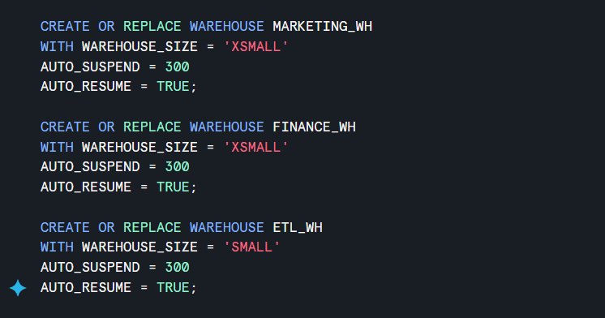

Output :
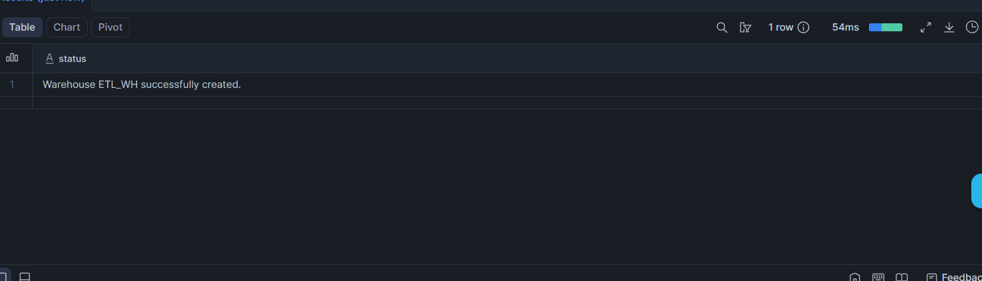

Observation
- ETL warehouse is assigned a larger size because ETL processing consumes more compute resources.
- Auto suspend helps reduce compute cost when warehouses are inactive.
- Auto resume automatically starts warehouses when queries are executed.

Part 2: Role Setup
Purpose
Roles are created to control access permissions in Snowflake.
The assignment requires three roles:
- Marketing Analyst
- Finance User
- ETL Developer

Create the role:


Grant Warehouse Access

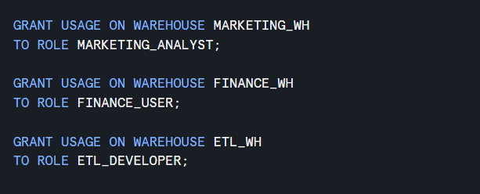

Output :
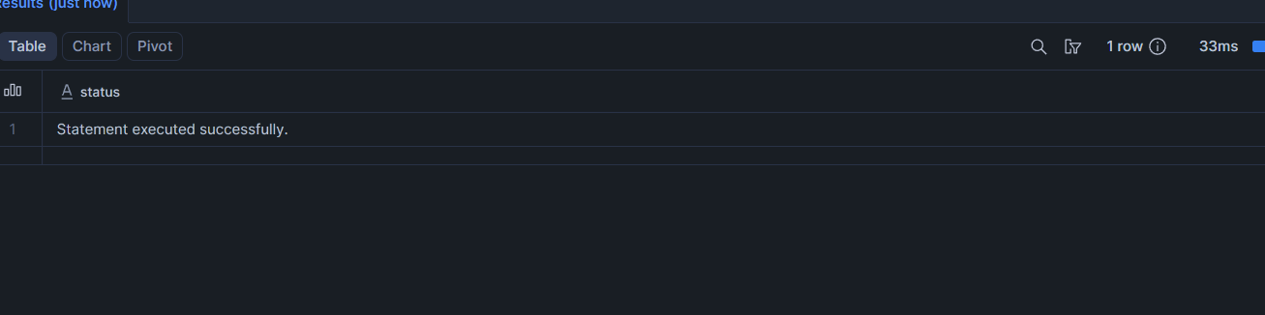

Observation
Each role can access only its assigned warehouse. This improves workload isolation and security.

Part 3: User Setup
Purpose
Users are created for each department and assigned default roles and warehouses.
The assignment requires:
- MKT_USER1
- FIN_USER1
- ETL_USER1

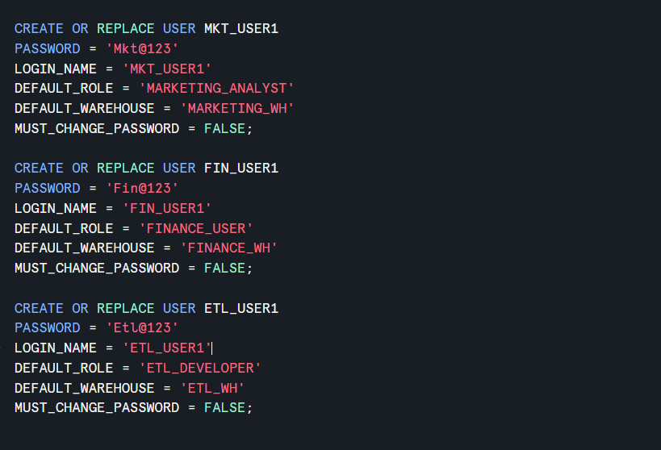
Grant Roles to Users


Output :
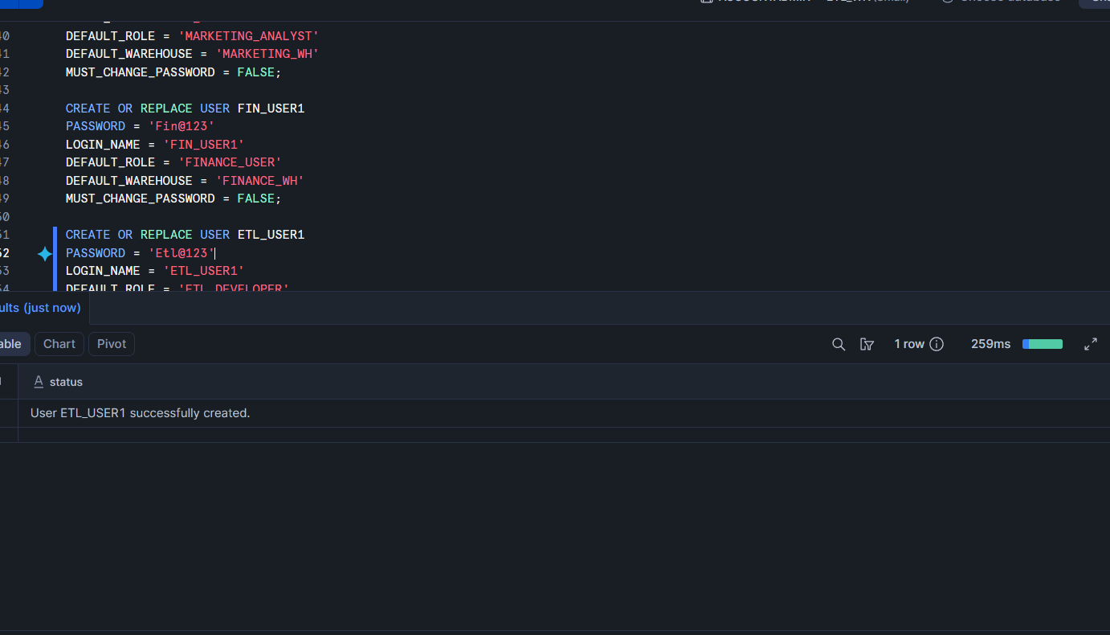

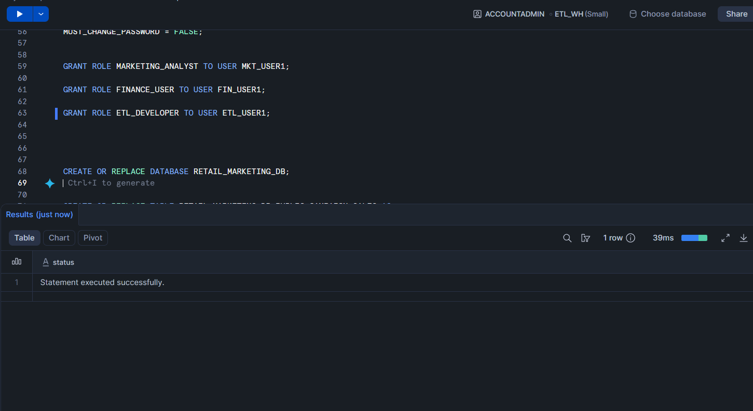

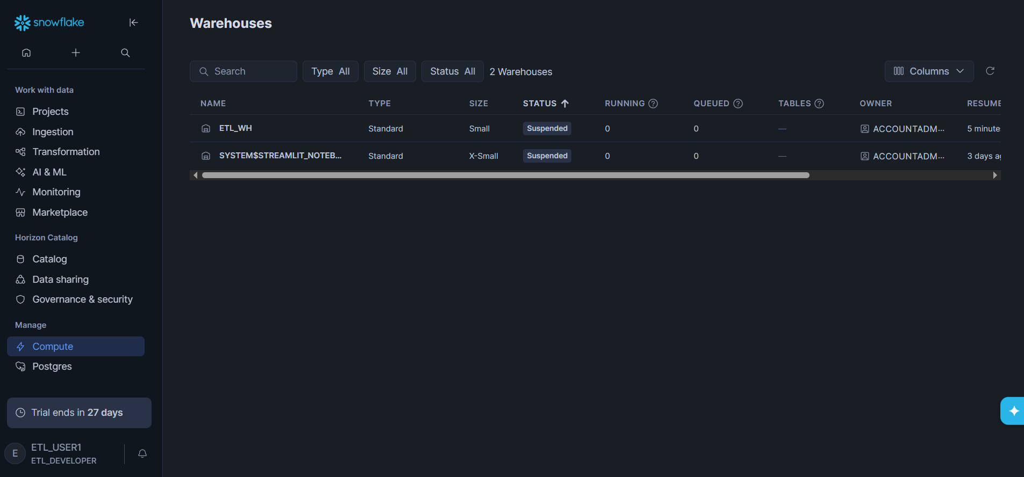
Observation
When users log in:
- Their assigned role becomes active automatically.
- Their assigned warehouse becomes active automatically.

Part 4: Database and Table Creation
Purpose
A new database named RETAIL_MARKETING_DB is created to store retail campaign analytics data.
The assignment requires creation of:
- Database: RETAIL_MARKETING_DB
- Table: CAMPAIGN_SALES

Create Database


Create Campaign Sales Table
The CAMPAIGN_SALES table is built using Snowflake sample retail datasets.
The assignment references:
- STORE_SALES
- CUSTOMER
- ITEM
- DATE_DIM

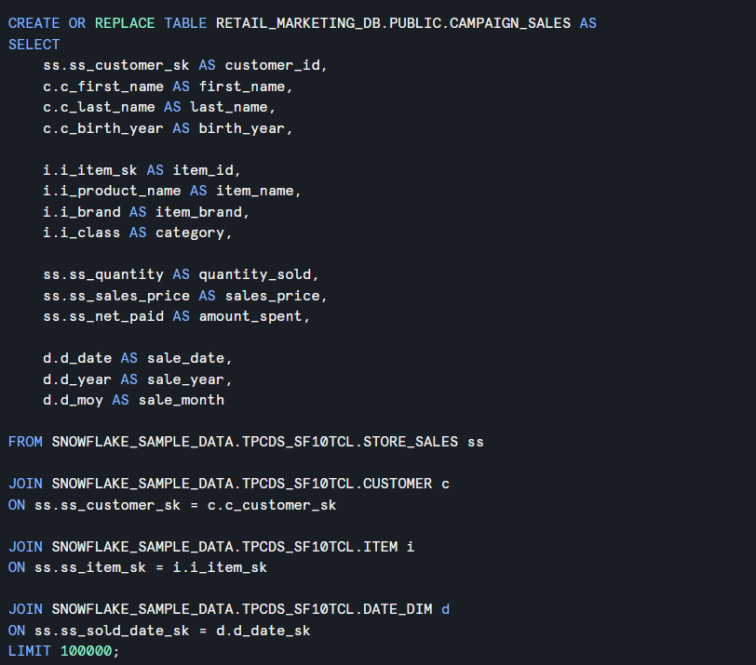

Verify Data


Output :
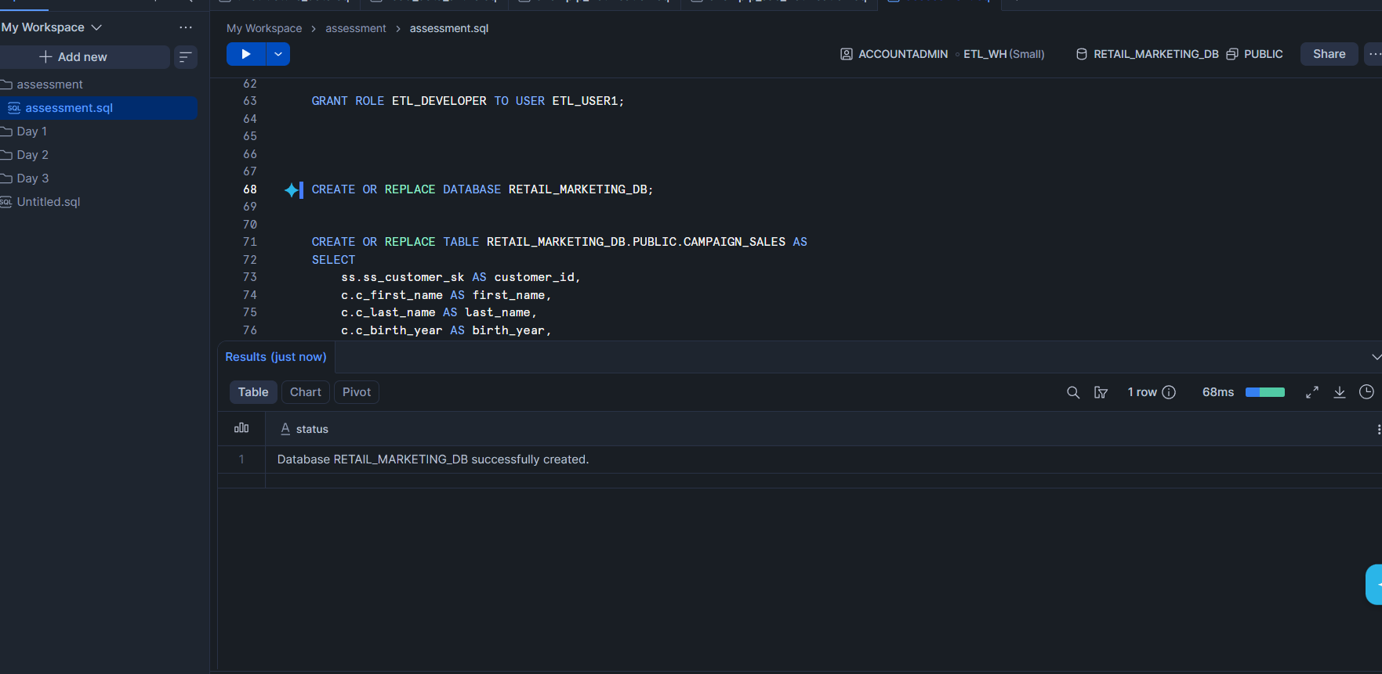

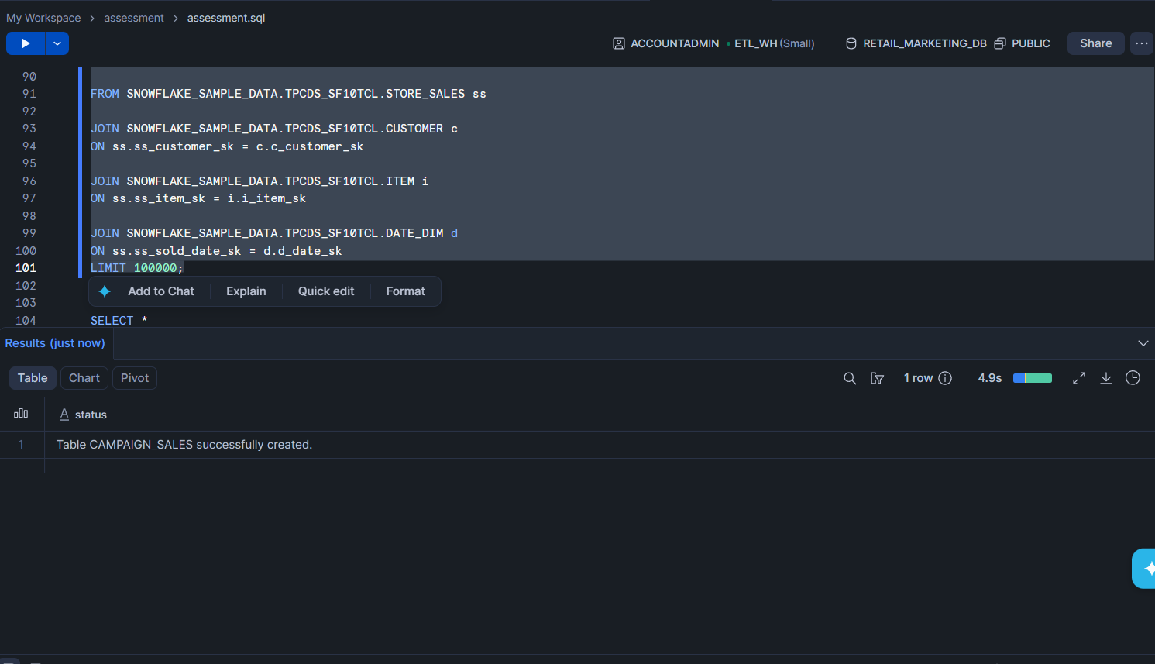

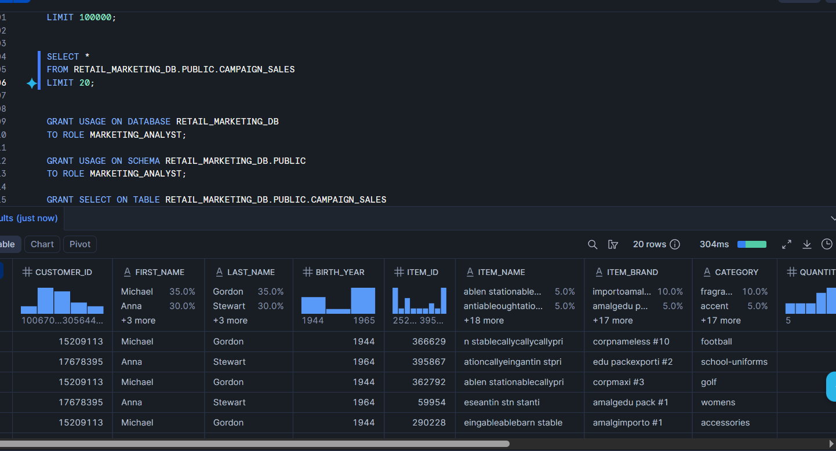
Observation
The table combines:
- Customer details
- Product information
- Sales metrics
- Date information
This creates a centralized analytics table for reporting and campaign analysis.

Part 5: Grant Permissions
Purpose
Access permissions are granted according to business requirements.
The assignment specifies:
- Marketing and Finance → Read-only access
- ETL Developers → Create and modify tables

Marketing Analyst Permissions
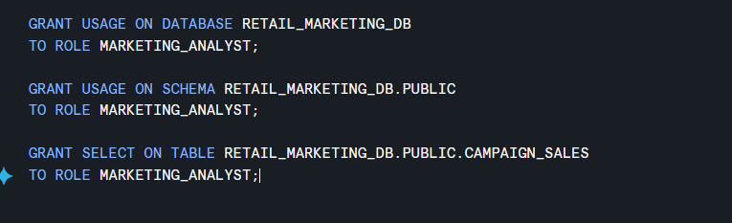

Output :
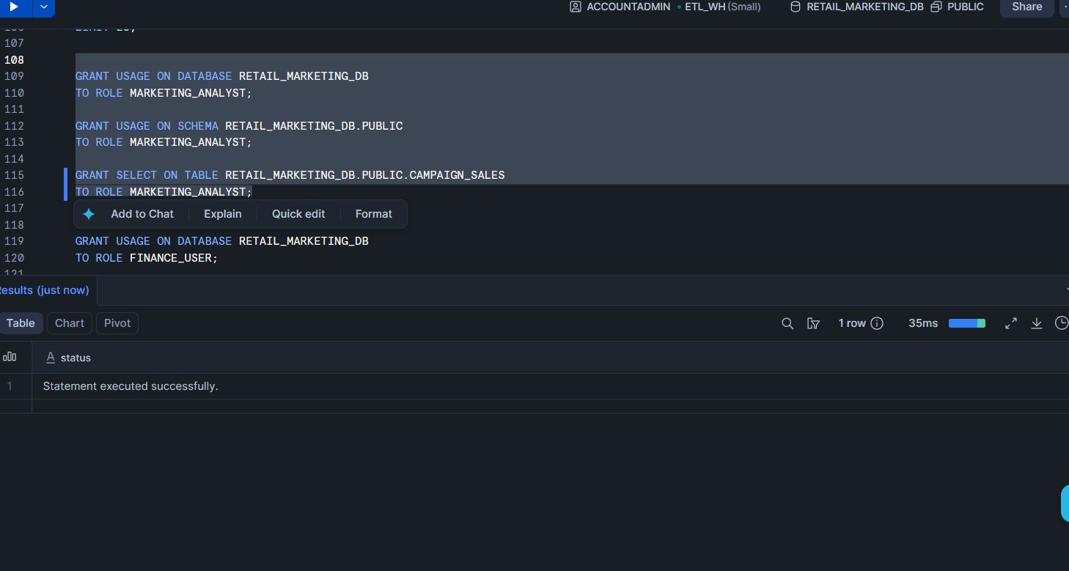

Finance User Permissions
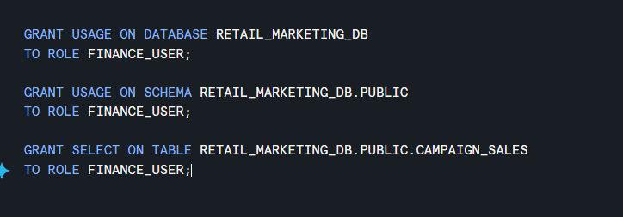

Output :
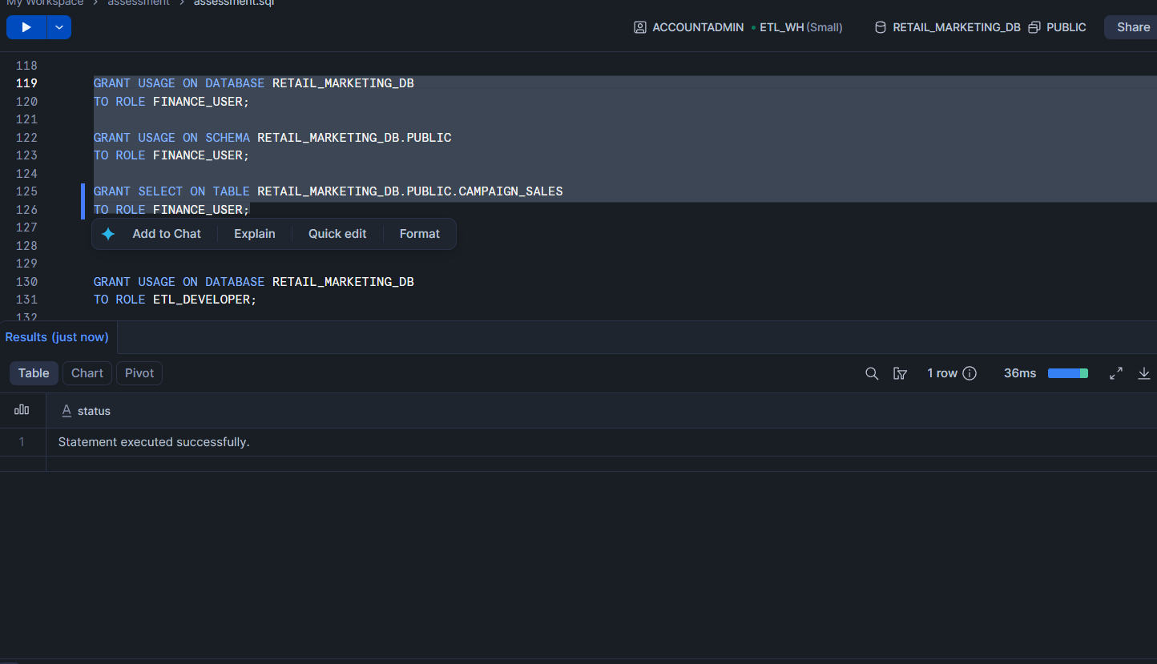

ETL Developer Permissions

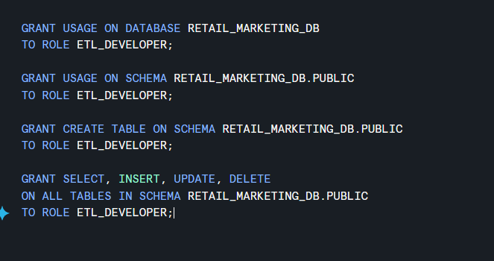

Output :


Observation
- Marketing and Finance users can only query data.
- ETL developers can modify and create database objects.

Part 6: Performance Testing using Warehouse Scaling
Purpose
Snowflake allows warehouses to scale up and down dynamically.
The assignment requires comparing query performance between:
- XSMALL warehouse
- SMALL warehouse

Run Query using XSMALL Warehouse


Output:
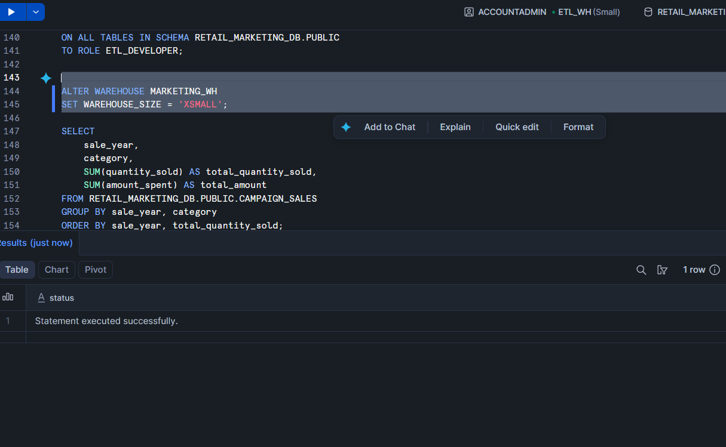

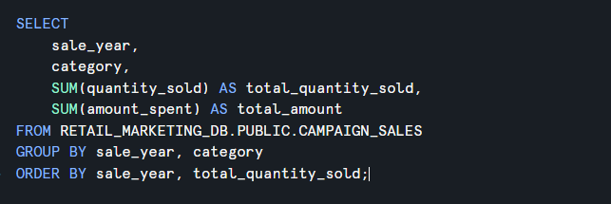

Output :
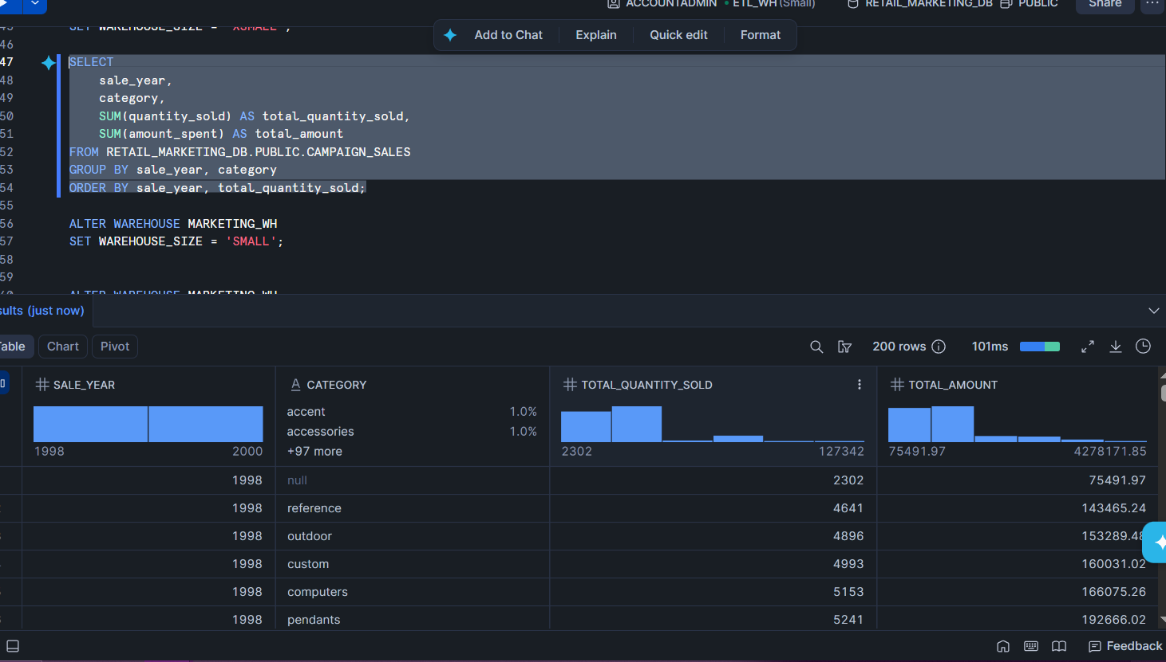

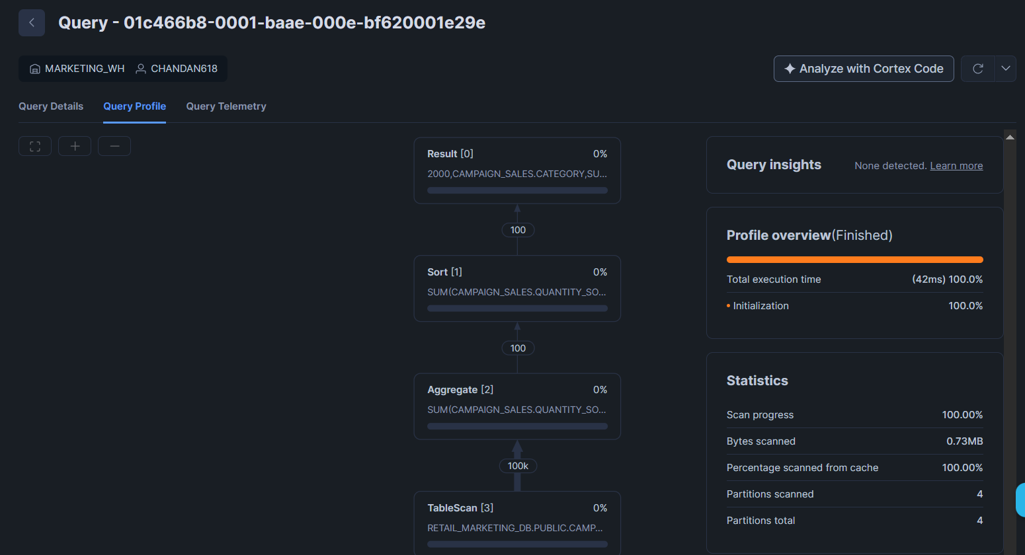
Observation
The XSMALL warehouse completed the query successfully but required more execution time.
Scale Warehouse to SMALL

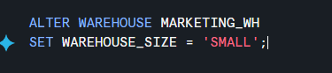
Output :
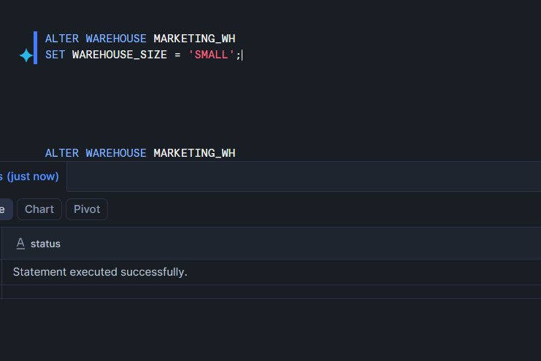

Run the same query again.
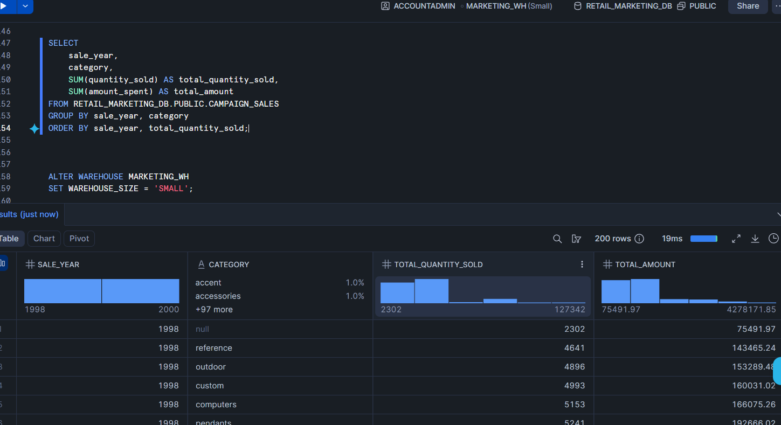

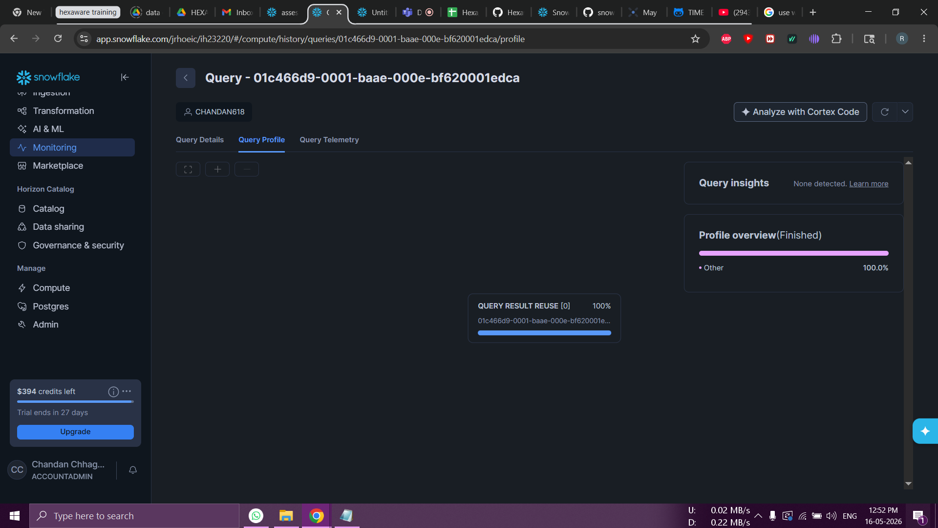

Observation
The SMALL warehouse completed the query faster because:
- More compute resources were available.
- Query processing power increased.

Scale Down Again
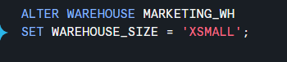

Part 7: Query Result Cache Testing
Purpose
Snowflake automatically stores query results in cache.
The assignment requires executing the same query twice and comparing execution time.

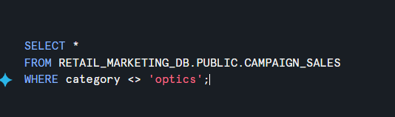

Output :
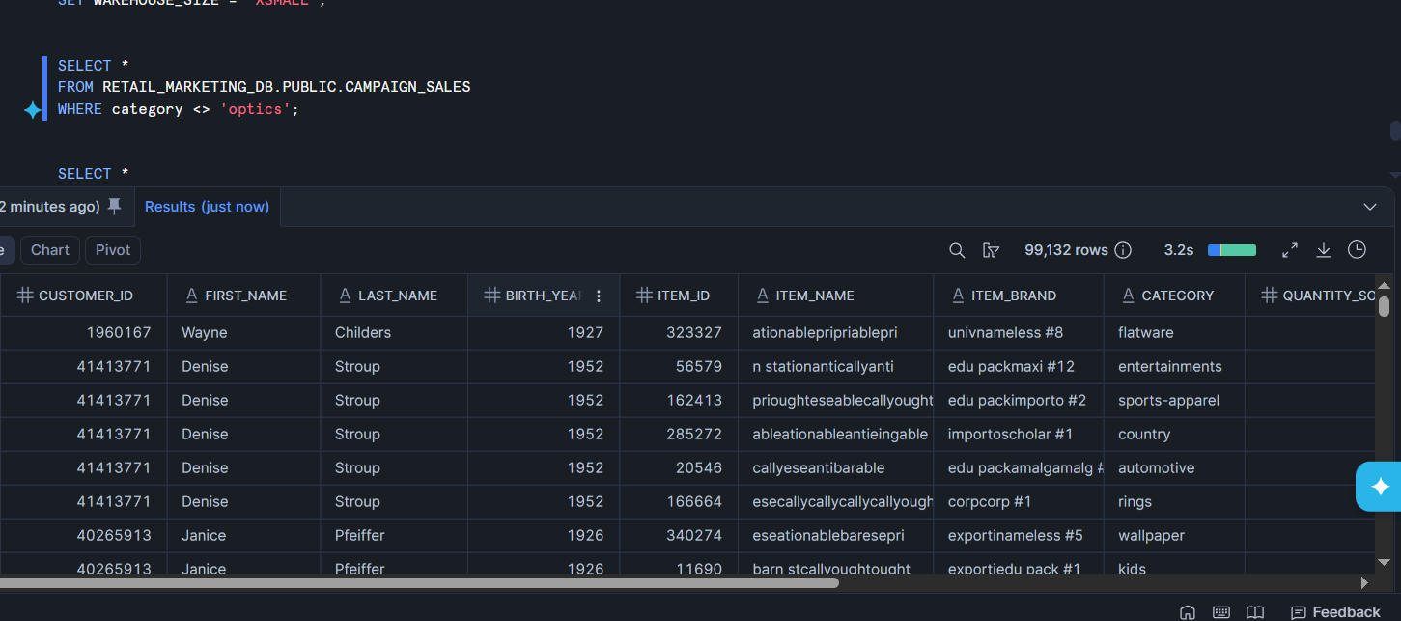

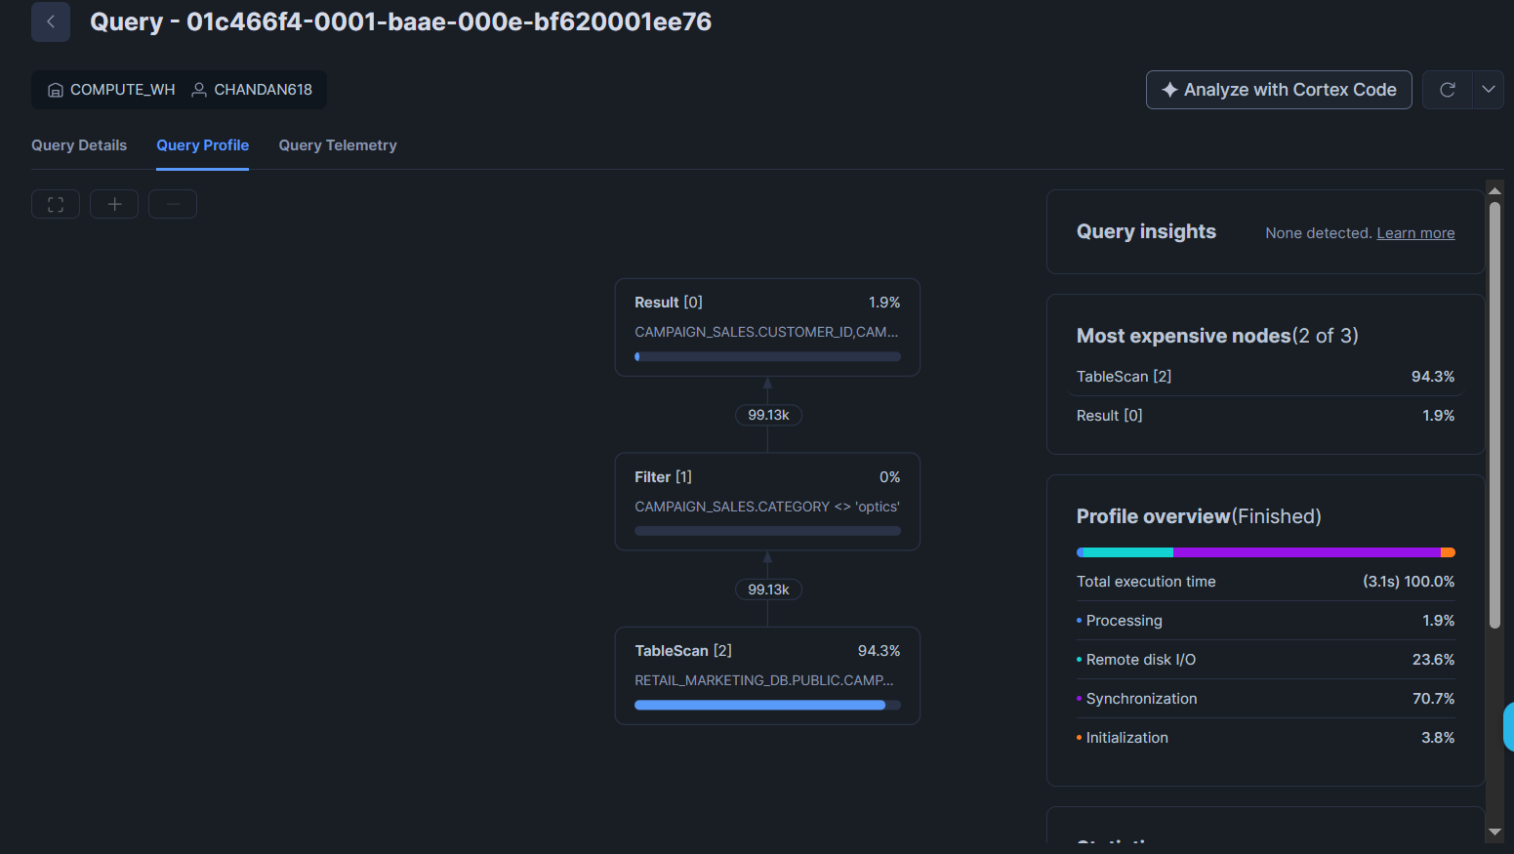
Run the same query again immediately.
Output : 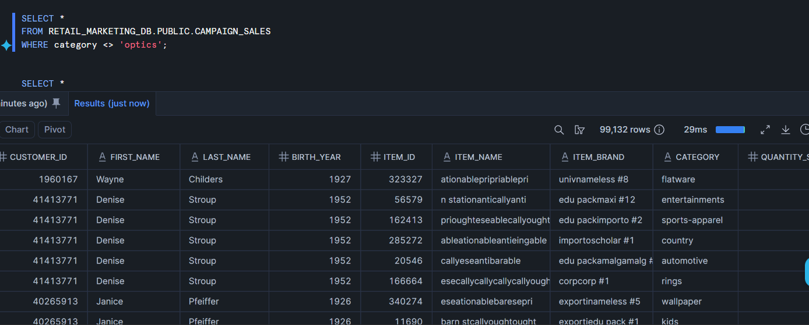
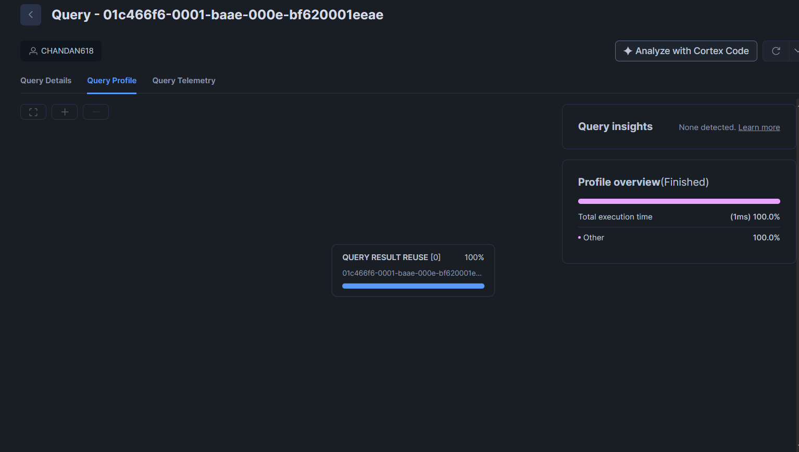

Observation
- First execution scans data and computes results.
- Second execution is significantly faster because Snowflake uses cached query results.
The sample report explains that unchanged query text, role, and data allow Snowflake to reuse the cached result.

Part 8: Cluster Key Testing
Purpose
Cluster keys improve query performance for filtering operations.
The assignment specifically asks to cluster on SALE_DATE.

Run Query before Clustering
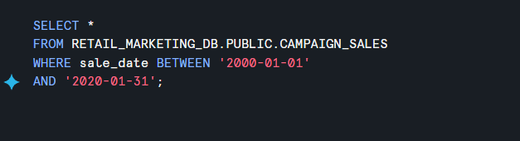
Output :
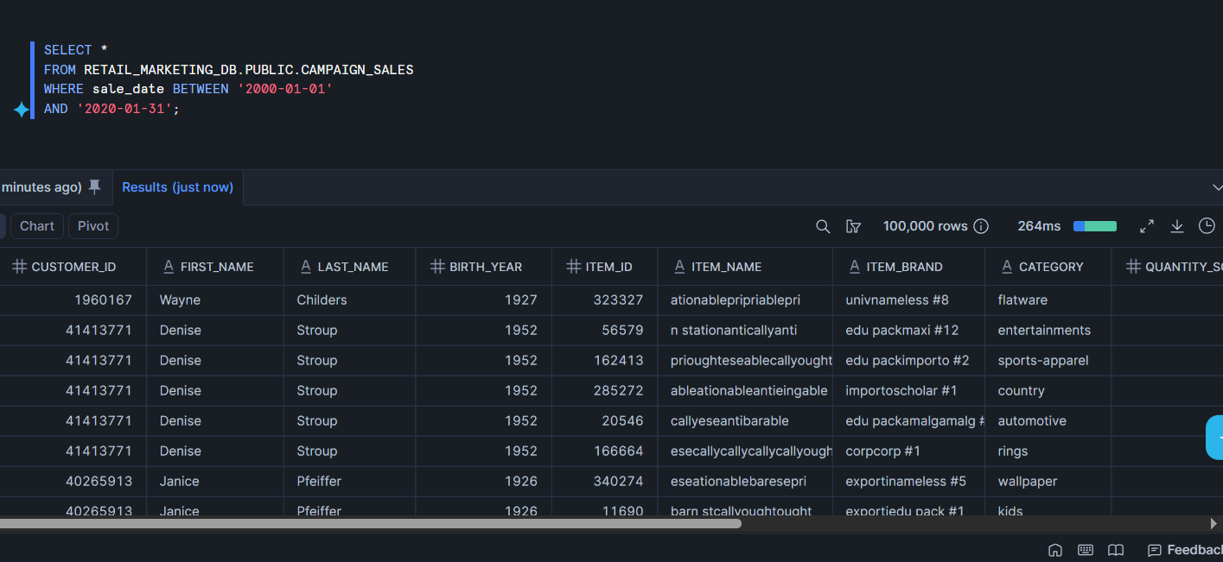
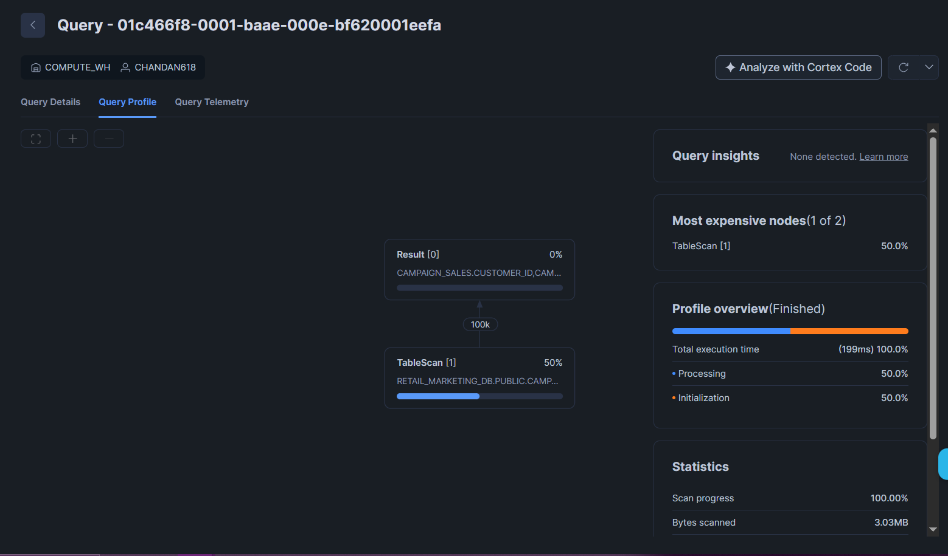

Add Cluster Key
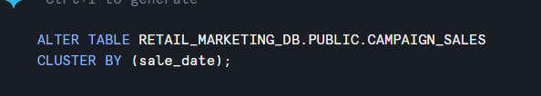
Output :
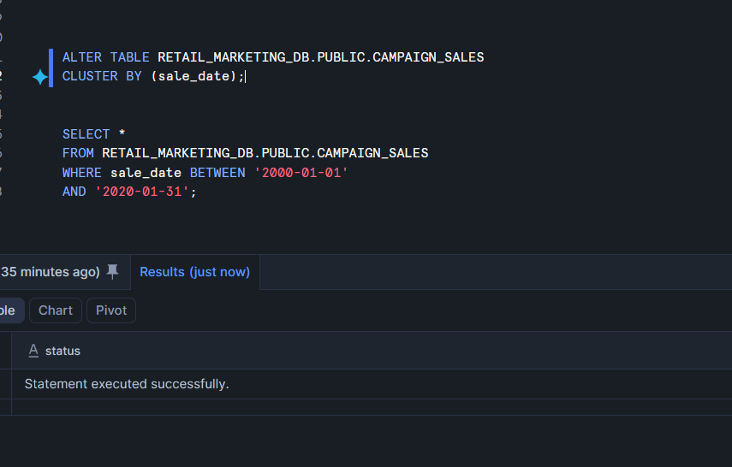

Run Same Query Again
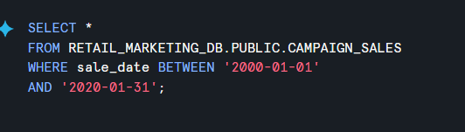

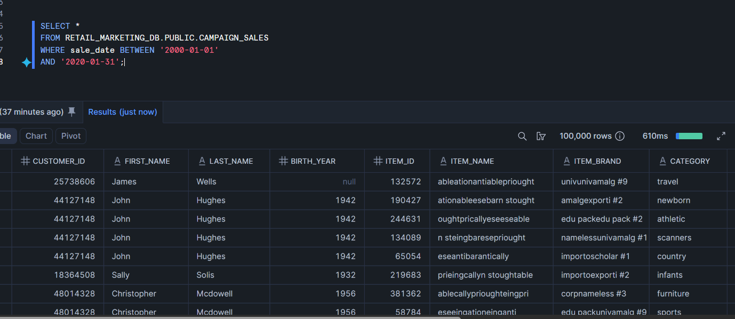
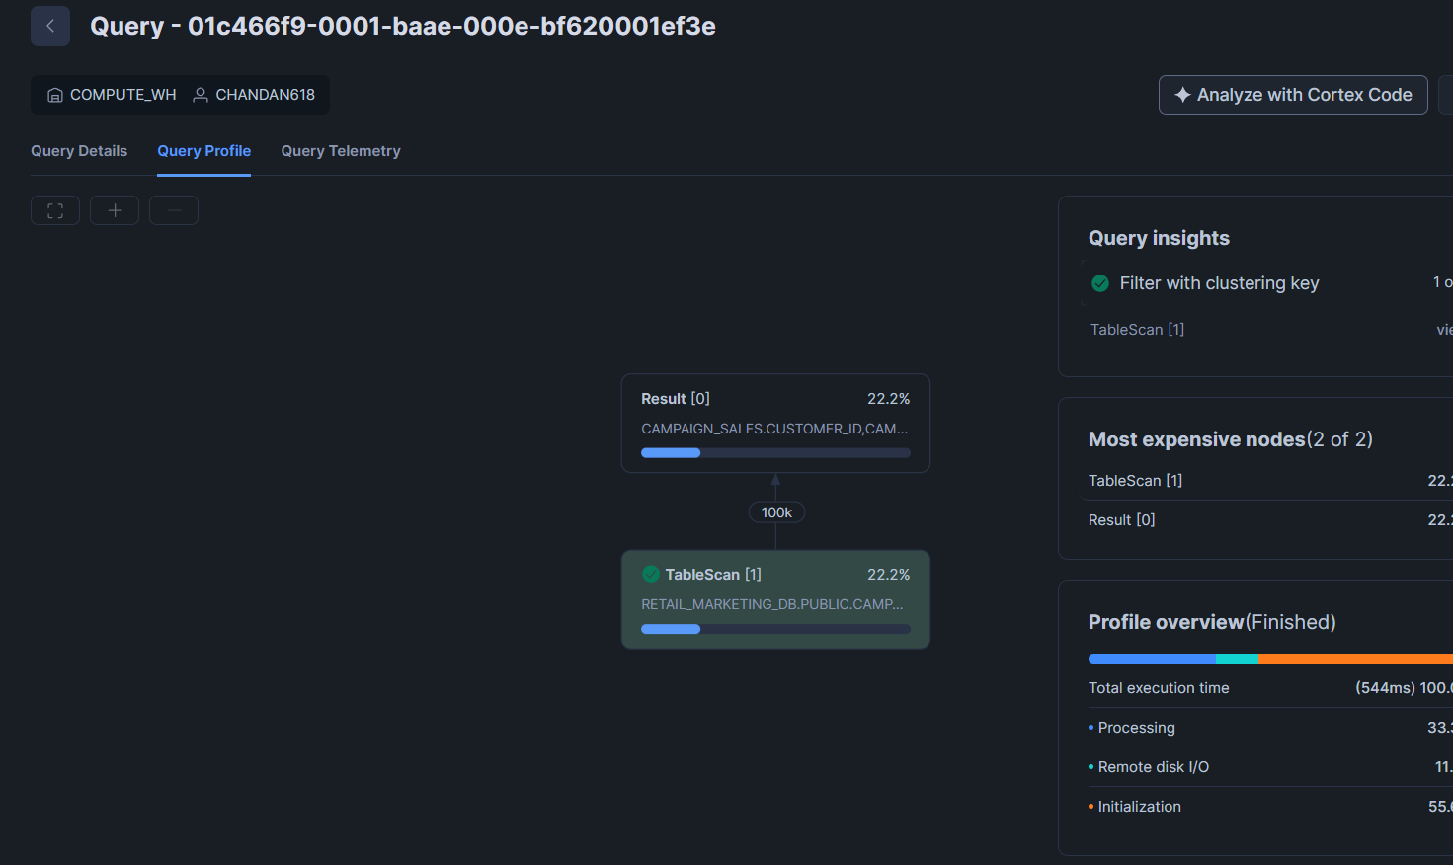
Observation
Before clustering:
- More micro-partitions were scanned.
- Query execution required additional processing.
After clustering:
- Snowflake scanned fewer partitions.
- Date filtering performance improved.

